TOOL FOR DESIGNED FUZZY SEMIOTIC CONTROL MODELS

Averkin A.N.
Computer center of Academy Science,

averkin@ccas.ru

Golovina E. Yu.
Moscow Power Engineering Institute, Applied Mathematics Department.
Krasnokazarmennaja, 14, 111250, Moscow, Russia.
Fax: 095-362.8938

Telex: 411610 MEI SU
Electronic mail: gol@apmsun.mpei.ac.ru.

Keywords: Fuzzy Controller, Fuzzy Control Model, Fuzzy Semiotic system, Fuzzy Tool

1. Introduction
Last years there is produced an extension of a mathematical means for intellectual systems. One of directions of researches in this area is the development of the theory of semiotic systems representing mathematical base for construction of intellectual systems qualitative of a new level. So, on change of the formal system and its partial modifications there comes the semiotic system allowing adequately to describe modern problem domains, importance characteristics which are an openness, dynamic, complex-structured. Academician RAES D.A. Pospelov is developer of the new approach to development of intellectual systems as of semiotic systems of simulation [1].
In the given paper are considered the approach to construction of the fuzzy semiotic system of control simulation within the framework of the theory of semiotic systems and its realization in the tool Trincon (Triangular Norm Controller).

2. Fuzzy semiotic system
Let's represent definitions 1 and 2 of semiotic systems formulated by the academician RAES, D.A. Pospelov, which we further interpret in the terms of a modern fuzzy mathematical apparatus.
Definition 1. The semiotic system is
SS={T,P,A,R,α(T),β(P),γ(A),σ(R)},
Where FS = {T, P, A, R} - formal system,
α,β,γ,σ - rule of change of element of FS.
Definition 2. (tightly coupled with definition 3) The semiotic system is
SS = {FS, ℵ},
Where FS = {FSi}, i = 1, n - set of formal systems,
ℵ= {ℵj}, J = 1, m - set of transitions from one of FS to another of FS.
At definition of the fuzzy semiotic system, as set of formal systems FS and set of transitions ℵbetween them, in quality FS any mathematical model, including model of worlds Nilson and Kripky, and also fuzzy control models can be used. Thus, at usage of fuzzy control models in quality FS we shall receive the following definition of the fuzzy semiotic system of control simulation.
Let's generalize definitions 1and 2 on an fuzzy case.
Definition 3 (generalization of definition 1). The fuzzy semiotic system of control simulation (μSS) is
μSS={T,P,A,R,Ω,α(T),β(P),γ(A),σ(R),ϕ(Ω)}, where
μFS={ T,P,A,R,Ω} - fuzzy formal system, where
T- set of terms;
P- set of rules of construction is correct - constructed formulas;
A - Set of the axioms;
R- set of the production rules;
Ω - Algebra (theoretical - multiple operations based on T-norms);
α,β,γ,σ,ϕ - rule of change of units μFS.
Definition 4 (generalization of definition 2). The fuzzy semiotic system of control simulation (μSS) is
μSS={{μFS_{i} },{ℵ_{j}}}, i=1,n; j=1,m,
Where n-number of fuzzy control models,
M-number of transitions between them.
Let's consider development of the fuzzy control system in a tool Trincon (Triangular Norm Controller) [7,8], operating in two modes:
- tuning of model of an fuzzy regulator on T-norms of the user;
- fuzzy semiotic control simulation.
For further presentation of a material we shall reduce definitions of fuzzy control model within the framework of the theory of fuzzy regulators, which is extended on T-norms and tightly is coupled with fuzzy semiotic control model (definition 4).

3. Fuzzy control model
Definition 5. The fuzzy control model is
Fuzzy Model = {T, PR},
Where T={t₁,t₂,…,t_{n}} - set of terms (linguistic variables),
PR={pr₁,pr₂,…,pr_{m}} - set of fuzzy product rules.
Definition 6. (extension of definition 1 on T-norms)
The fuzzy control model is
Fuzzy Model ' = {T, PR, T-norm},
Where Fuzzy Model = {T, PR},
T-norm={<T₁,S₁>,<T₂,S₂>,…,<T_{n},S_{n}>},
<T_{i},S_{i}> - couple T-norm and T-conorm.
For processing Fuzzy Model ' the rule generalized Modus Ponens, extended on T-norm is used. The extension generalized Modus Ponens on T-norms allows to adjust fuzzy control model to T-norms of the user and, thus, adequately to present model of problem domains [2,3,4].
Let's reduce algorithm of operation of an fuzzy controller WARP, designed SGS-THOMSON corporation (Italy) [5], which ascends to algorithm of an fuzzy controller of H.Watanabe [6], by expanding it on a apparatus of T-norms.
Step 1. The fuzzification stage. The input is coded by uniting all values that correspond to input variables and are read from a data unit.
Step 2. The stage of the alpha-values computation. The coded input is compared with fuzzy sets of antecedents with the aim of estimating their membership degree with respect to linguistic values.
The a-values of product rule are defined under the formula:
α_{i}=Т (α₁^{i} , α₂^{i} , ..., α_{m}^{i}) ( i=1..n), where
α_{i} -α -values antecedents of a i- th product rule;
n - number of a simultaneously selected product rule;
m - number antecedents in a i-th product rule;
α_{ij} (j = 1.. m) -α- values of a j-th antecedents of a i-th product rule.
Step 3. The inference stage. Alpha-values obtained from antecedents modify membership functions of consequences. The maxmin method, and the maximal points method are most known among methods for the determination of the output value. By us is realized the maxmin method. The maxmin method performs the section of the consequent membership function at the level of the antecedent alpha-value. The next step is the combination of these fuzzy sets with the aim of computing the unique value of the output variable. This value is found as a sum of modified fuzzy output sets, which is the new fuzzy set G. The sum can be computed in two ways: either as a logical sum, which corresponds to the logical operator maximum, or as a arithmetical sum, which corresponds to the summation from point to point of the values of the membership function. We realize a method of logical sum for obtaining the new output function of an accessory appropriate output variable extended on S-norms.
Step 4. The defuzzification stage. In this step, the output (precise) value of the fuzzy controller is defined on the basis of the fuzzy set G. There exist many defuzzification methods, namely:
- the bary center method;
- the centering method, which we realized in Trincon tool;
- the maximum middle method.

4. Tool of fuzzy semiotic control modeling
Some versions of a tool Trincon v.1.0-v.6.0 now are developed, from which each subsequent version is the extension of functionalities previous.
The tool Trincon is "tining" above program environment WARP-SDT (Weight Associative Rule Processor Software Development Tool) [5] created by the SGS-THOMSON corporation (Italy) in 1994. The fuzzy control model, designed in environment WARP-SDT, is the initial model for a tool Trincon, in which is carried out fuzzy semiotic control modeling with tuning of models on T-norms of the user.
In a basis of a tool Trincon the algorithm of operation of an fuzzy controller extended on usage of T-norms and S-norms lays. The T-norms are used at definition -α -values of product rules, the S-norms are used at definition of the membership function of the output variable obtained as united of output membership functions, appropriate to the given output variable, simultaneously selected product rules. The T-norm also is used at definition of a degree of reliability of the information, read - out from sensors.
In a tool Trincon the tuning of fuzzy control model on the following T-norms is carried out:
1) T-norm and S-norm Zade:
T1 (x, y) = min (x, y) S1 (x, y) = max (x, y);
2) Probability T-norm and S-norm:
T2 (x, y) = x · y S2 (x, y) = x + y - x · y;
3) T-norm and S-norm of Lukasiewitch:
T3 (x, y) = max (0, x + y - 1) S3 (x, y) = min (1, x + y)
4) T-norm and S-norm of Frank: p> 0
T4(x,y)=log_{p} $\left[1+\frac{(p^{x}−1)(p^{y}−1)}{p−1}\right]$;

S4(x,y)=1-log_{p} $\left[1+\frac{(p^{(1−x)}−1)(p^{(1−y)}−1)}{p−1}\right]$;
5) T-norm and S-norm of Cugeno: s ≥ -1
T5 (x, y) = max [0, x + y-1-s (1-x) (1-y)];
S5 (x, y) = min [1, x + y + s*x*y],
And also there is an tuning on hybrid T-norms.
Subsystems of tool Trincon are:
- solver, based on the rule of generalized Modus Ponens, extended on T-norm;
- subsystem of loading of input data, which the fuzzy control models and initial tests;
- subsystem of saving of application results of fuzzy control model;
- subsystem of tuning fuzzy control model on hybrid T-norms;
- subsystem of visualization of operation of fuzzy control model with support 2D- and 3D-graphs;
- subsystem of dynamic tuning of T-norm;
- subsystem of support of fuzzy semiotic control modeling;
- subsystem of support of multitasking;
- subsystem of the help.
In a subsystem of support of fuzzy semiotic control modeling the change of fuzzy conrol models is produced at origin of an external action, which is imitated by right button click. Choice of hybrid T-norms and fuzzy control model for further operation of the control process further is produced. Thus last state of the previous fuzzy control model is the first state for subsequent. In a tool Trincon the transitions are produced which are described by a cube of transitions, prepresented in a fig. 1. Generally cube of transitions is 4-arny, as in Trincon the parametric T-norms are realized. On fig.1 the following denotations are used: M = {M1, M2, …, Mn} - set of fuzzy control models; T = {T1, T2, …, Tm} - set of T-norms; S = {S1, S2, …, Sm} - set S-norm.
In a subsystem of tuning of fuzzy control model on hybrid T-norms there is an tuning of each output value of model on own T-norms.

Fig.1 A Cube of transitions in Trincon
The subsystem of visualization of operation of fuzzy control model works in two modes:
- "Modeling", in which the dependences of values of output variable from input variables are showed;
- "Simulation", in which the dependences of values of output variables from current time of the control process are showed.
The subsystem of visualization is the multifunction component. Its main functionalities are:
- support of different kinds of the 2D-graphs;
- support of different kinds of the 3D-graphs;
- scaling of coordinate axises;
- change of layout of a beginning of coordinates;
- deleting of the graphs.
In a tool Trincon the visualization of dynamic behaviour of the technical object, i.e. review of the characteristics of its time behaviour is realized at continuous change of models of handle. For this purpose are used 2D- and 3D- of a graphics. If for control of some parameter of the object some models are used, then for showing dependence of some parameter from time the graph is used, in which the points are showed by geometrical figures (circle, ellipse, sector, rectangle), defining current control model.
The subsystem of tuning of fuzzy control model on hybrid T-norms has convenient resources for the definition of parameters in parametric T-norms Frank and Sugeno, which are a horizontal and vertical scrolling bar.
Interface of tool Trincon is presented in fig.2.

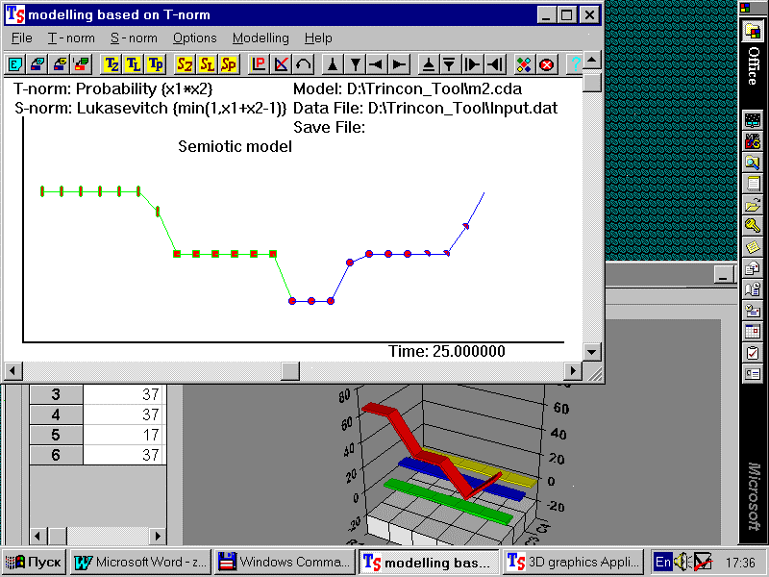

Fig.2 Interface of tool Trincon

Conclusion
In work the approach to construction of a mathematical apparatus of fuzzy semiotic control systems in frameworks of semiotic modeling proposed by the academician RAES dr. D.A. Pospelov is represented. Designed the fuzzy semiotic model is put in a basis of a tool Trincon.
This work was supported by the Russian Fund of Fundamental Researches.

Literature
1. Pospelov D.A. Situation Control, an Overview. Proceedings of Workshop on Russian Situation Control and Cybenetic /Semiotic modeling. Editor R.J. Strohl. Battelle Columbus Ohio, USA, 1996, pp.7-37
2. Averkin A.N. Decision Making Based on Multivalued Logic and Fuzzy Logic. Architectures for Semiotic Modeling and Situation Analysis in Large Complex Systems, Proceedings of the 1995 ISIC Workshop, 27-29 August, Monterey, California, 1995.
3. Averkin A.N, .Pospelov D.A., Tarasov A Managing Linguistically “ Soft Computing, Concurrent Engineering, What Else?. V.B Verdaguer, San Paulo, Brazil, July 22-28, Vol. 2, 1995.
4. Averkin A. N. “ Fuzzy Logics Simulation Technology in General Strategy of Intelligent System Designing. Proceedings of the Second International Conference on Application of Fuzzy Systems and Soft Computing, edited by R.A.Aliev, K.W.Bonfig, F.Aliev, F.Wieland, ICAFS'96, Siegen, Germany - June 25-27, 1996.
5. A.Pagni, R. Poluzzi, G.G.Rizzotto WARP: Weight Associative Rule Processor. An Innovative Fuzzy Logic Controller. IIZUKA'92-2ND International Conference on Fuzzy Logic and Neural Networks, 1992.
6. H.Watanabe, W.M.Dettloff and K.E. Yount A VLSI Fuzzy Logic controller with Reconfigurable Cascadble Architecture. IEEE Journal of solid-state circuits, Vol. 25, No 2, April 1990.
- Averkin A.N., Golovina E.Yu., Sergeevskii A.E. Development of Fuzzy Controllers on the Base of Triangular Norms.- Journal of Computer and Systems Sciences International, Vol.36,No.5,1997, pp.757-763
- Averkin A.N., Golovina E. Yu., Krug P.G.. The system of tuning of model of fuzzy controller on logic of the user. – Proceedings of VI national conference with international paticipantion (CAI-98). Pushino (Russia).- 1998, pp.350-355 (vol. 1).

